Monitoring ONEAXI – rev. 2

Contents

1 SITE CONFIG PRTG 1

1.1 General settings 1

1.2 Remote Site TO Internet DMM latency 1

1.3 Remote Site TO VPN DMM latency 2

1.4 Remote Site Bandwidth IN USE 3

2 PRTG config DMM 5

3 GRAFANA CONFIG 7

# SITE CONFIG PRTG

## General settings

Monitor type:

* ICMP Ping
  + Latency
* SNMPv2C
  + Bandwith in use

Monitoring interval: 30s

Test IP address in Lux: 82.143.66.193 (This is the Telenet router IP address in DMM)

## Remote Site TO Internet DMM latency

New sensor for ONEAXI (DEVICE = DMM INTERNET)

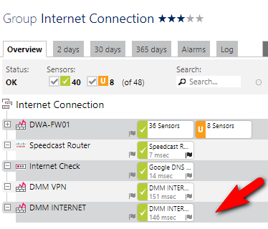

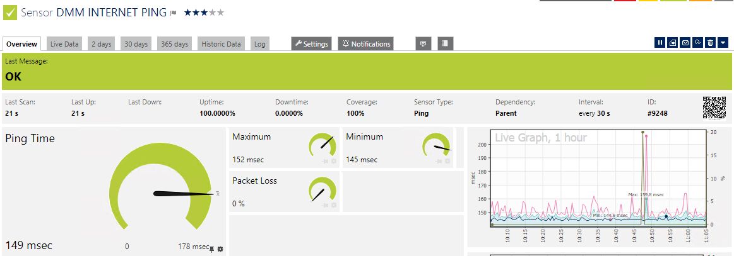

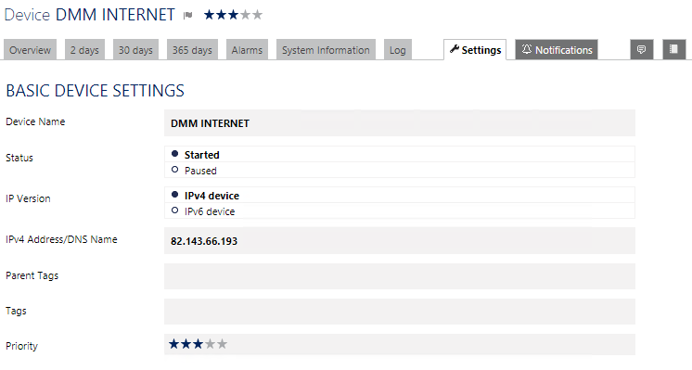

## Remote Site TO VPN DMM latency

New sensor for ONEAXI

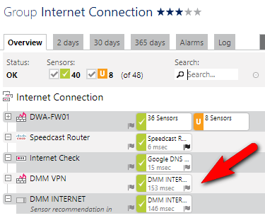

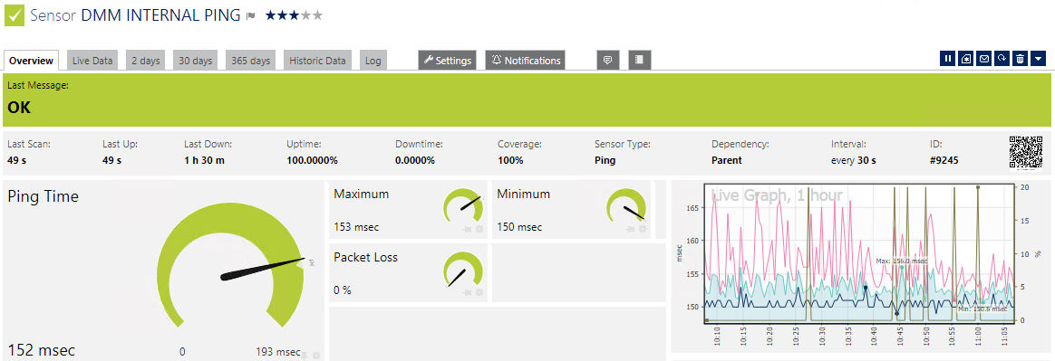

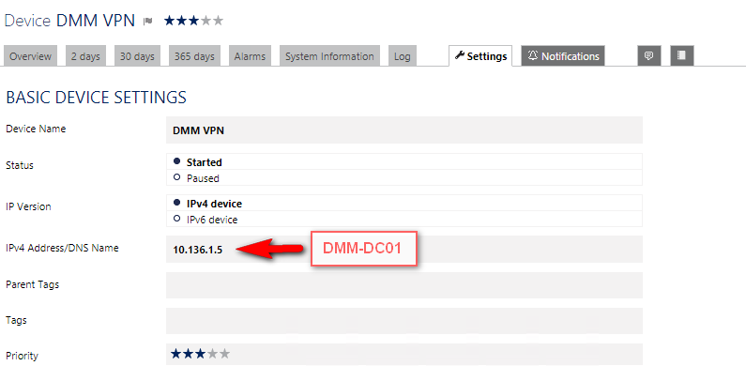

## Remote Site Bandwidth IN USE

**Existing sensor (new standard)**

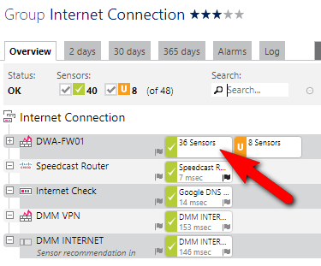

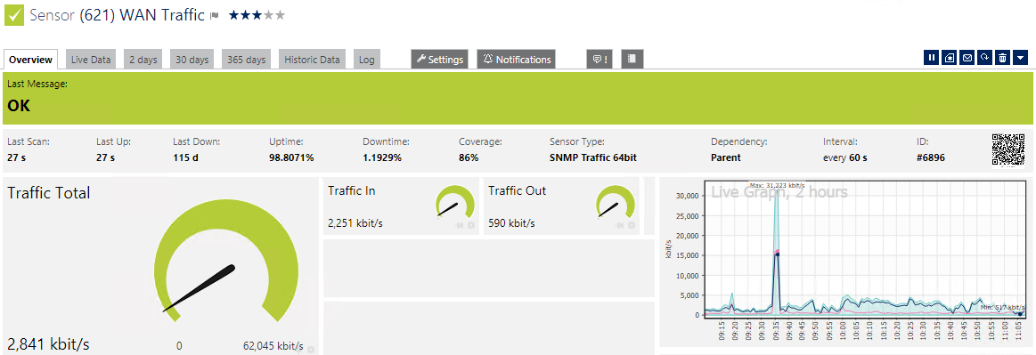

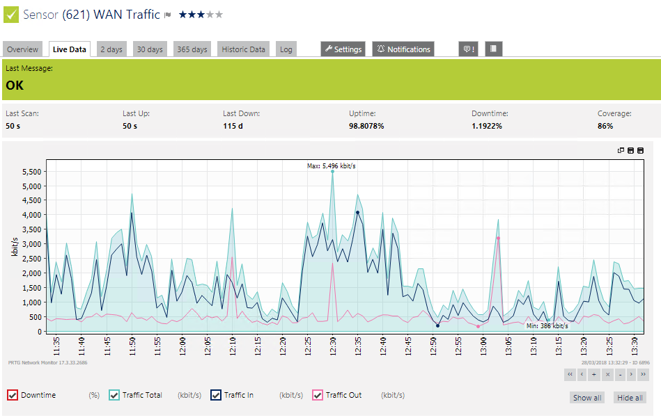

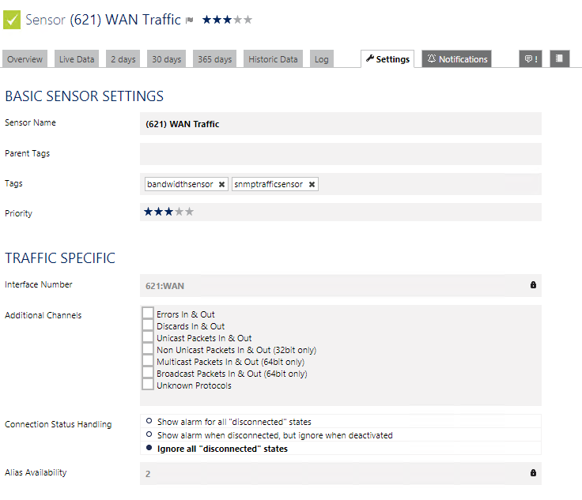

# PRTG config DMM

DMM-PRTG02 > Capellen > ONEAXI network monitoring

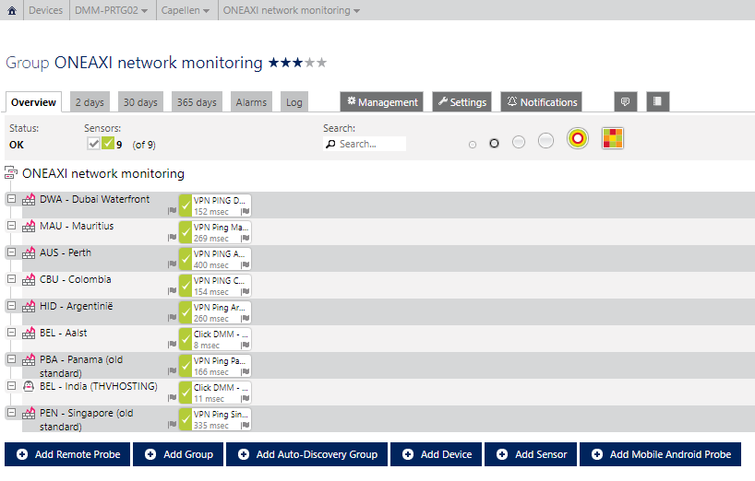

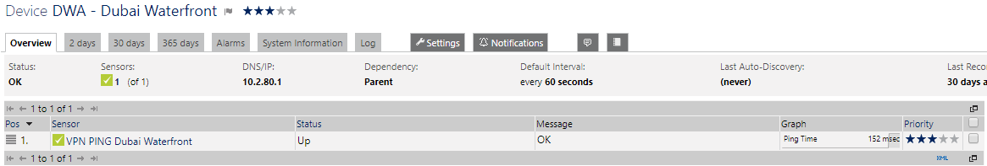

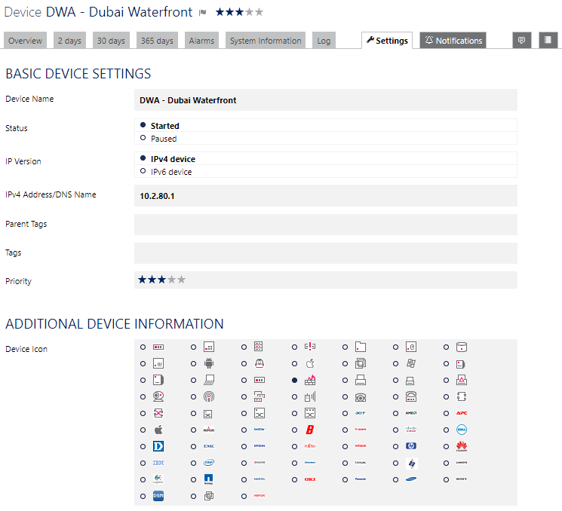

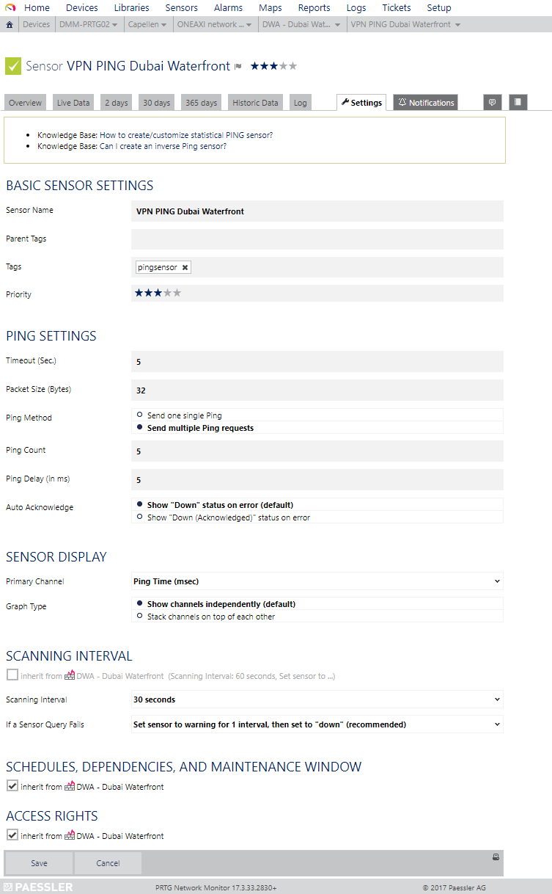

# GRAFANA CONFIG

Login: <http://vm-sql-grafana:3000> (always use Chrome, credentials can be found in RDM)

Configuration – Data Sources – Add data source

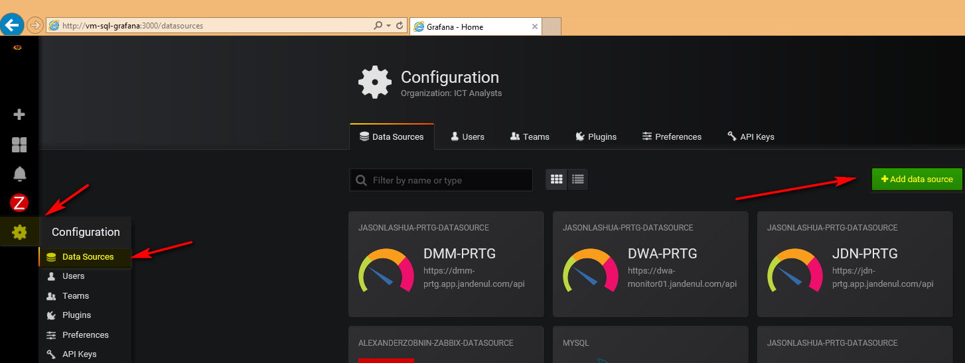

Fill in name, type, URL (= https prtg url + ‘/api’), access mode = proxy

Unfortunately, due to a self-signed certificate on most PRTG nodes, we need to enable the “skip TLS verification” until further notice.

Username = prtgadmin (or another admin use)r

Passhash = passhash of the PRTG admin user (= NOT the password, see further)

Enable “timezone auto-adjust”

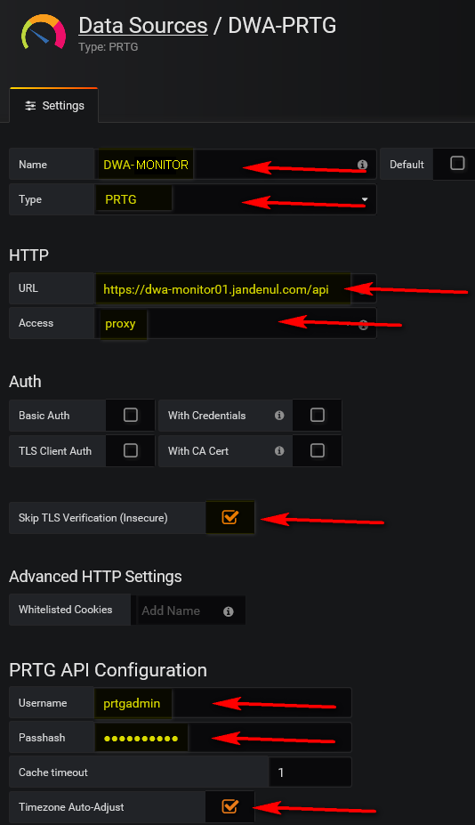

To find out the passhash of a user: login to prtg

Setup – system administration - user accounts

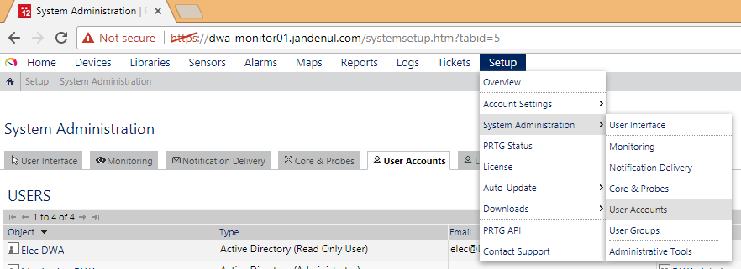

Select a user

“Show passhash”

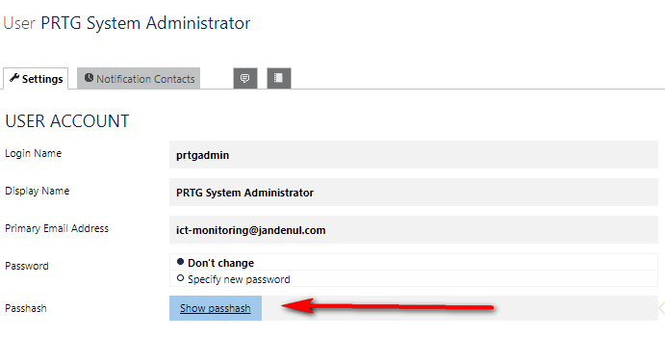

While viewing the prtgadmin properties, scroll down and check the timezone settings of the user

Should be “UTC +1 Brussels”, else you will see gaps in the grafana graphs

